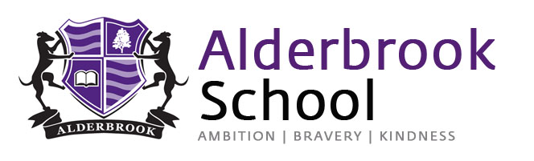

Exam Application Form – Autumn 2021

Name____________________________________________________________
DOB _____________________________________________________________
Candidate Email Address _____________________________________________
Contact Phone Number _______________________________________________
6th Form/College attending 2021/22 (If applicable)__________________________
*Access Arrangements requirements (e.g. reader, scribe) ____________________

Subject | Tier of Entry, H or F – if applicable | Exam Board | Exam Code

All subjects will be exam based only. Non Exam Assessment/Coursework will not be included in the autumn season.
Forms must be returned to the exams office (exams@alderbrook.solihull.sch.uk) by the following dates to enable entries to be made by the exam board deadline.
A Level – 3rd September 2021
GCSE – 17th September 2021
Once entries have been made you will be contacted with a confirmation email, plus date of exams etc.

Parents Signature_________________________________________
Student Signature_________________________________________
Date____________________________________________________

*Students must have been assessed by Mrs Brown and arrangements were in place for summer 2021 season.

For Exams office use only
Entry Made | Student emailed confirmation | 6th Form/College informed – if applicable | Timetable issued | Student emailed results | 6th Form/College informed of results –if applicable

