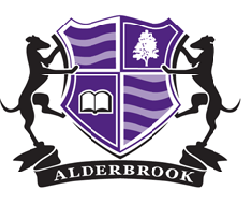

Year 6 Transition

Getting to know Alderbrook

|  |  |
| --- | --- |
| **GETTING TO KNOW YOUR NEW SCHOOL** | **[https://www.alderbrookschool.co.uk/wp-content/uploads/2019/07/Alderbrook-School-logo-tablet.jpg](https://www.alderbrookschool.co.uk/)** |
| **The guide to help you start Year 7 fully prepared** | |

**MESSAGE FROM YOUR HEAD OF YEAR:**

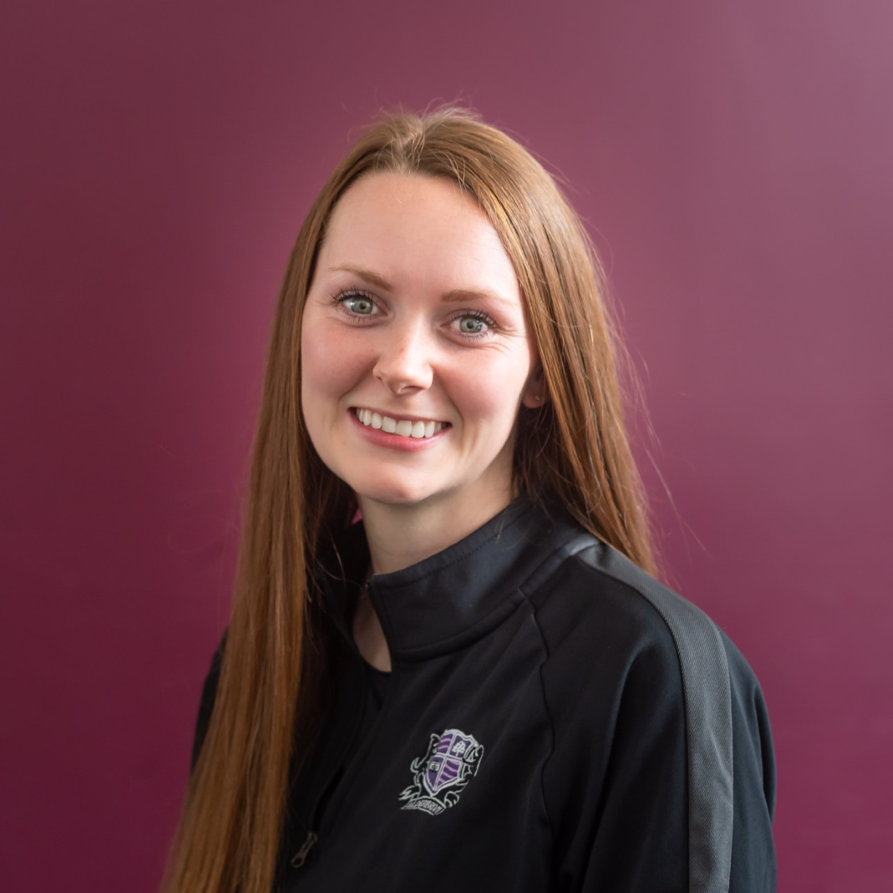 

Watch this tour by Mr Beveridge and answer the questions below:

****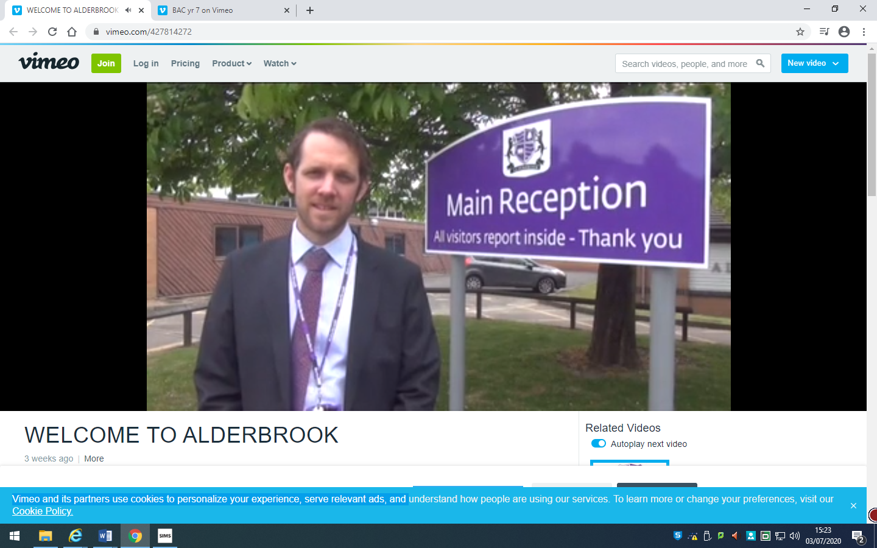

1) Where is the main entrance of the school? __________________________________________

2) Where is the second entrance? __________________________________________________

3) what is the main hall called? What is the hall used for? ________________________________

4)What is the sports hall called? ______________________________________________

5) Why is Pupil Reception an important place for you? ___________________________________

6) Where is the main canteen? _________________________________________________________

**School website**

<https://www.alderbrookschool.co.uk/>

Remember that you can view our website if you need any additional information about Alderbrook School.

|  |  |
| --- | --- |
| **TIMETABLE** | **[https://www.alderbrookschool.co.uk/wp-content/uploads/2019/07/Alderbrook-School-logo-tablet.jpg](https://www.alderbrookschool.co.uk/)** |
|  | |

**At Alderbrook, we operate a 2-week timetable. This is an example of how it will look:**

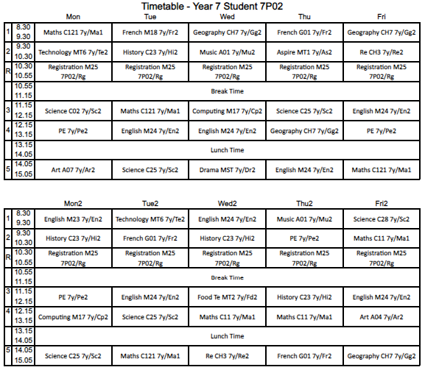

1. Count how many English, Maths and Science lessons you have in 2 weeks:
   1. English: __________
   2. Maths: __________
   3. Science: ___________
2. Count how many PE, Geography and French lessons you have in 2 weeks:
   1. PE: _________
   2. Geography: __________
   3. French: __________
3. Look for the timings of the school day and answer the following questions:
   1. How long is a lesson? _____________
   2. How many lessons do I have each day? ______________
   3. How long is Lunch Time? _____________
   4. What time is Form Time? ______________
   5. What time is the start and end of the school day? Start: _____________/ End: _______________
   6. What days would you need to bring in your PE kit in Week 1? ______________/ ______________/
4. Each classroom starts with a letter and then a number (e.g. M18)
   1. What classroom is Music in? __________________
   2. What classroom is Art in? __________________

**Alderbrook School Ground Floor Map**

TASK: Look at the timetable on page 1. Can you find any of the rooms for the lessons on this map?

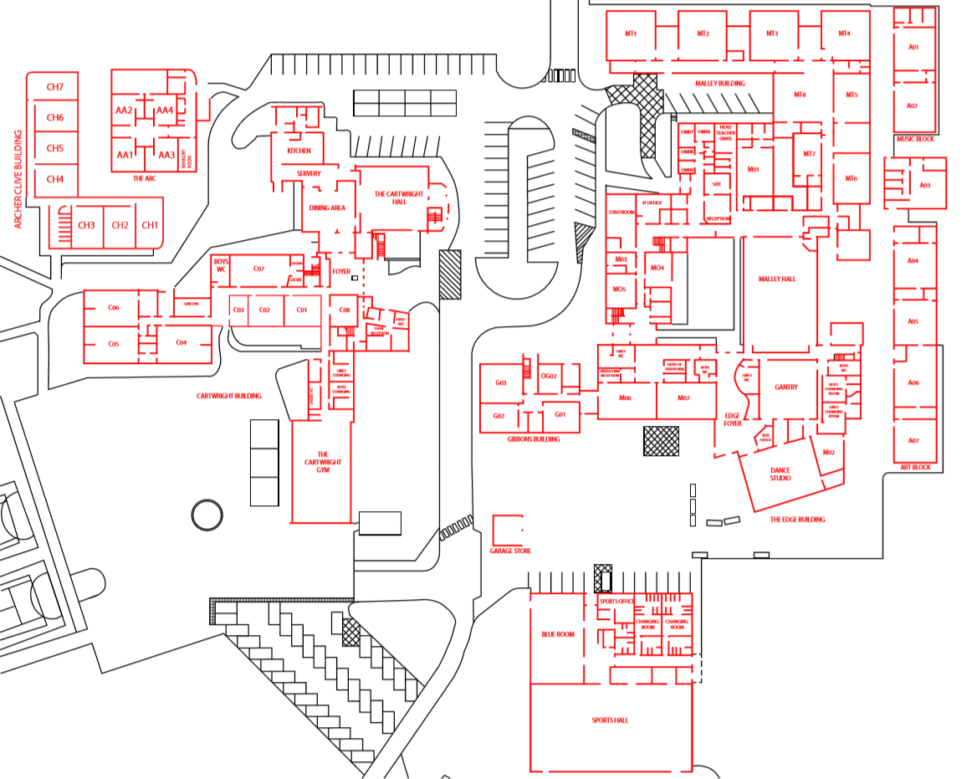

**Alderbrook School First and Second Floor Map**

TASK: Look at the timetable on page 1. Can you find any of the rooms for the lessons on this map?

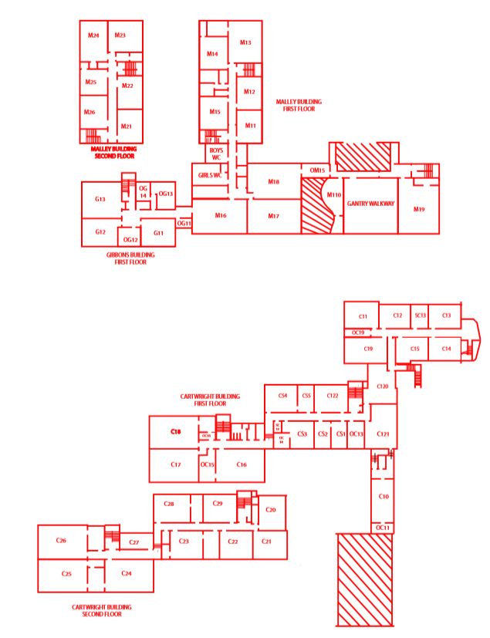

|  |  |
| --- | --- |
| **PACKING YOUR BAG** | **[https://www.alderbrookschool.co.uk/wp-content/uploads/2019/07/Alderbrook-School-logo-tablet.jpg](https://www.alderbrookschool.co.uk/)** |
|  | |

|  |
| --- |
| It is important that you come to Alderbrook fully prepared for your day. This includes packing the correct items in your bag every day and wearing the correct uniform. |

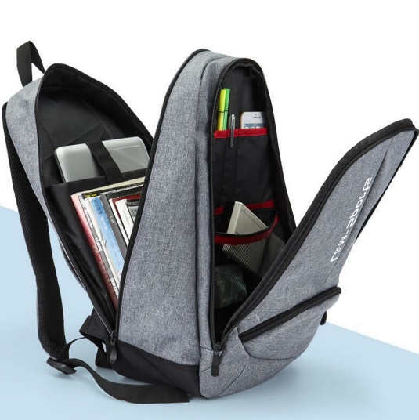**Packing your bag**

|  |
| --- |
| All students are required to have at least 5 basic pieces of equipment, every day:  • Pens – black and green  • Ruler  • Pencil  • Planner  • Scientific calculator  Task:  Look at Monday’s lessons and write down anything else that you will need to put in your bag  (remember that you must look after your books for your subjects) |

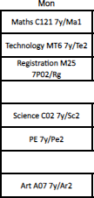

|  |  |  |
| --- | --- | --- |
|  |  | ITEM |
| 1 |  |  |
| 2 |  |  |
| 3 |  |  |
| 4 |  |  |
| 4 |  |  |
| 5 |  |  |
| 6 |  |  |
| 7 |  |  |
| 8 |  |  |
| 9 |  |  |
| 10 |  |  |

|  |  |
| --- | --- |
| **UNIFORM** | **[https://www.alderbrookschool.co.uk/wp-content/uploads/2019/07/Alderbrook-School-logo-tablet.jpg](https://www.alderbrookschool.co.uk/)** |
|  | |

**At Alderbrook, we are very proud of our school uniform and appearance.**

Task:

Below are some of our uniform rules, **BUT, 2 are incorrect**. Highlight the 2 incorrect rules:

1. **Make-up** - Make-up of any kind is allowed
2. **False Nails** - False, acrylic or gel nails are not to be worn in school. Also coloured/varnished nails are not acceptable.
3. **False Eyelashes** - False eyelashes in school environments are also unacceptable
4. **Jewellery** - Students are not permitted to wear any jewellery except a watch
5. **Shirts-** Should be tucked in.
6. **Piercings** - Any piercings are allowed
7. **Skirts**—Skirts should be pleated and with the embroidered Alderbrook ‘A’. They should be fitted to touch the knee and not worn rolled up.
8. **Trousers** - no flared, cargo pants, denim, nylon/Lycra, tight or cropped trousers.
9. Overcoats - no suede, leather coats, denim or ‘denim style’ jackets, slogans or hooded tops
10. **No baseball caps**
11. **Hair** - No extreme haircuts: no shaved sides of head or patterns, avoid anything less than a #2 cut and no extreme hair colouring.
12. **Shoes** - Black only - no trainers or canvas pumps

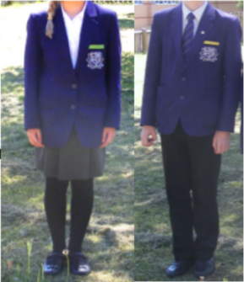

**Why is wearing the correct uniform important?**

..

Our ABK values apply to the way we choose to conduct ourselves, the way that we behave towards other people and the way that we behave in our lessons.

The expectation that we have is that we all behave in a way that means that we are calm, collected and respectful towards one another, and that we arrive for our lessons punctual and prepared.

|  |  |
| --- | --- |
| **ALDERBROOK’S VALUES** | **[https://www.alderbrookschool.co.uk/wp-content/uploads/2019/07/Alderbrook-School-logo-tablet.jpg](https://www.alderbrookschool.co.uk/)** |
|  | |



**Ambition**

**Bravery**

**Kindness**

Apologising if you have done something hurtful

Giving someone a compliment

Turning up on time to lessons

High level of respect shown to all

Working successfully as part of a team

Going above and beyond with your work

Being respectful to other staff and students

Saying good morning to people as you pass

Having your shirt tucked in neatly

Holding the door open for a teacher

Contributing to lessons

Supporting others

Standing in front of the class and talking about a topic

Turning up on time to lessons

Acting as an form representative

Staying calm if something goes wrong

Discussing issues with a teacher

Remembering your homework

Turning up on time to lessons

Asking for help when needed



|  |  |
| --- | --- |
| **ALDERBROOK’S VALUES** | **[https://www.alderbrookschool.co.uk/wp-content/uploads/2019/07/Alderbrook-School-logo-tablet.jpg](https://www.alderbrookschool.co.uk/)** |
|  | |

At Alderbrook School, part of our learning is called ‘LIFE READY’. In these sessions and in our ‘LIFE READY’ days, we focus on learning about the skills and characteristics that students will need in the ‘big, wide world’. Our learning is focused on the three values of our school:

**AMBITION** – being the best that you can be and positioning yourself to be happy and fulfilled

**BRAVERY** – learning about difficult topics; making a stand; resilience and determination

**KINDNESS** – planning how to be kind to others and ensuring that you are kind to yourself

**#AMBITION**

**DREAM and DO**

David Beckham is thought to have been one of the most focussed sports stars in the world. He was always motivated and driven by his passion for football and for being the best footballer that he could be.

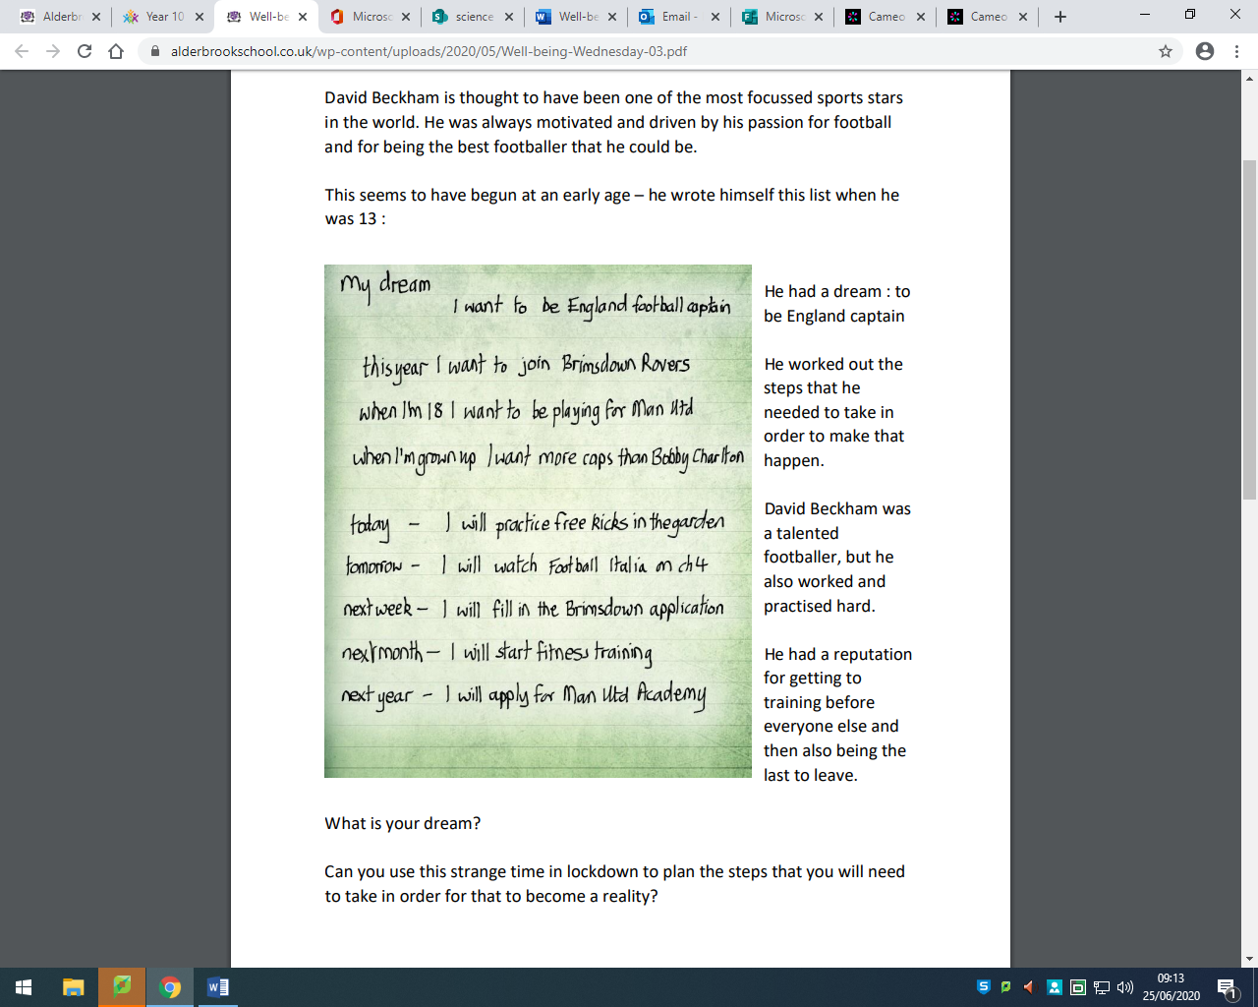

This seems to have begun at an early age – he wrote himself this list when he was 13:

He had a dream: to be England captain.

He worked out the steps that he needed to take in order to make that happen.

David Beckham was a talented footballer, but he also worked and practised hard. He had a reputation for getting to training before everyone else and then also being the last to leave.

**What is your dream? ­­­­­­­­­­­­­­­­___________________________________________**

Can you use today to plan the steps that you will need to take for that to become a reality?

What will you do today? _______________________________________________________________________

What will you do tomorrow? ___________________________________________________________________

What will you have done by this time next week? _______________________________________________

What will you have done by September? _______________________________________________________

What will you have done by Christmas? ________________________________________________________

What will you have done by this time next year? ________________________________________________

**#BRAVERY**

**MOVING TO SECONDARY SCHOOL**

You don’t need to be worried about coming to Alderbrook – although it’s ok to be nervous.

**Nervous means that it’s important.**

Lots of people get nervous – performers get nervous before they go on stage, sports stars get nervous before they walk into the stadium, teachers get nervous before they teach a new subject or a new group.

**Nervous means that you want to do your best.**

At Alderbrook, we would like you to be brave.

Brave doesn’t mean fearless.

Brave means willing to try to do things that are hard.

Brave means not giving up.

Brave means sticking with it.

Brave sometimes means standing up for the right thing.

**So … a few questions for you to think about:**

1. Have there been sometimes in year 6 when you have been brave? (a time when you haven’t given up or a time where you have kept trying)
2. What questions would you like to be answered by teachers at Alderbrook?
3. Who are the bravest people that you can think of?

**#KINDNESS**

**THANKFULNESS and WELL-BEING DIARY**

Over lockdown and probably over the coming months, the things that we can do with our family and friends have been and will continue to be limited. This has often resulted in boredom and worry.

It has been shown that one of the best coping strategies is to be kind. Be kind to others and kind to yourself.

**KINDNESS TO OTHERS – THANKFULNESS**

Take a few moments to think about what you are thankful for.

Can you write or draw some of the things in the box?

Take a few moments to think about people that you are grateful to.

Can you practise writing thank you notes to some of the people that have been good to you?

When you are at home you could write some actual thank you notes and send them to the people who deserve them – imagine how pleased they will be!

|  |  |
| --- | --- |
| **FAQs** | **[https://www.alderbrookschool.co.uk/wp-content/uploads/2019/07/Alderbrook-School-logo-tablet.jpg](https://www.alderbrookschool.co.uk/)** |
|  | |

You will probably have lots of questions about coming to Alderbrook. Members of staff at Alderbrook school have tried to answer some important questions for you. Click on the link and fill in the answers. <https://www.alderbrookschool.co.uk/year-6-7-transition/>

**Mr Coggan**

Question: Are there any groups, activities or clubs that I can take part in at the school?

Answer:**_______________________________________________________________________________**

**Ms Jones**

Question: How will my parents know how well I am doing?

Answer:**_______________________________________________________________________________**

**Ms Thandi**

Question:Who will look after me when I start at Alderbrook?

Answer:**_______________________________________________________________________________**

**Mrs Read**

Question**:** How will I know what lessons I’ve got?

Answer:**_______________________________________________________________________________**

**Mr Beveridge**

Question: What do I do when I get lost?

Answer:**_______________________________________________________________________________**

[**Mr Stent**](http://demo.goodlayers.com/realfactory/market-sectors/construction-engineering/)

Question: When I come to Alderbrook, how many different teachers will I have?

Answer:**_______________________________________________________________________________**

**Mr McLoughlin**

Question: How much homework will I get?

Answer:**_______________________________________________________________________________**

[**Mrs Allen**](http://demo.goodlayers.com/realfactory/market-sectors/construction-engineering/)

Question: What is the best thing about Alderbrook?

Answer:**_______________________________________________________________________________**