**Revision websites for GCSE media revision**

1. Check class charts or Teams. Your Teacher will have sent you an invite to **Senecca Learning**. All the topics that come up in the exams are on there.

app.senecalearning.com/dashboard/join-class/deknsew6yb

1. Watch the **Becky Fisher youtube videos**. She has videos on ALL the set texts for component 1 and 2.

[GCSE Media - Pride Magazine - Media Language & Representation - YouTube](https://www.youtube.com/watch?v=FAsXMQr3LLw)

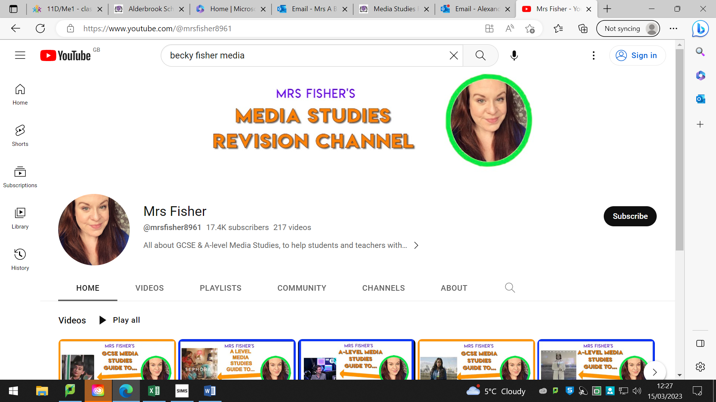

1. **ALL The factsheets for component 1:**

[Resource (eduqas.co.uk)](https://resources.eduqas.co.uk/Pages/ResourceSingle.aspx?rIid=950)

ALL the factsheets for component 2 :

[Resource (eduqas.co.uk)](https://resources.eduqas.co.uk/Pages/ResourceSingle.aspx?rIid=1602)

[Resource (eduqas.co.uk)](https://resources.eduqas.co.uk/Pages/ResourceSingle.aspx?rIid=1053) (don’t forget, the music videos we are studying are Bad Blood by Taylor Swift, Justin Bieber’s Good intentions and TLC Waterfalls for context. I can’t see any fact sheets on the Eduqas site for intentions..)