Post-results services: request, consent and payment form Summer 2025
To request a Review of Results (RoR) service and/or an Access to Scripts (ATS) service, complete the required information in the white boxes and then students must sign and date the form to confirm the required consent. A summary of the services available are referenced below.
Deadlines for request - See documents in results pack or school website-under students/examinations.
Candidate number |  | Candidate name |  | Candidate email
Awarding Body | Qualification level and Subject title |  |  | Paper code | SRN * | Fee | Paid by
 |  |  |  |  |  | £ | cash/chq/ParentPay
 |  |  |  |  |  | £ | cash/chq/ParentPay
 |  |  |  |  |  | £ | cash/chq/ParentPay

RoR Candidate consent
By signing here, I give my consent to the head of my school or college to submit a clerical re-check or a review of marking for the examination(s) listed above. In giving consent I understand that the final subject grade and/or mark awarded to me following a clerical re-check or a review of marking, and any subsequent appeal, may be lower than, higher than, or the same as the result which was originally awarded for this subject.

ATS Candidate consent
By signing here, I consent to my scripts being accessed by my Centre (Tick ONE of the boxes below)
If any of my scripts are used in the classroom, I do not wish anyone to know they are mine. My name and candidate number must be removed.
If any of my scripts are used in the classroom, I have no objection to other people knowing they are mine.

Date:
Date:
Consent statements above and details of the RoR services below taken from Post-Results Services

SRN* | Post-results service | Details of the service
R1 | RoR Service 1 (Clerical re-check) | This is a re-check of all clerical procedures leading to the issue of  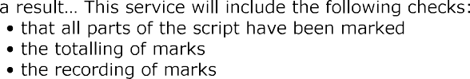
R2 | RoR Service 2 (Review of marking) | 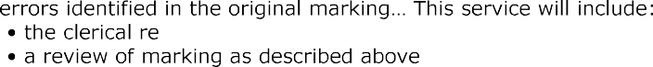  This is a post-result review of the original marking to ensure that the agreed mark scheme has been applied correctly... Reviewers will not re-mark the script. They will only act to correct any  -checks detailed in Service 1
R2P | RoR Service 2a Priority (Review of marking) | This is the same as Service 2 above but the review is conducted as a priority by the awarding body. This service is only available for GCE A-level qualifications - university students.
R3 | RoR Service 3 (Review of moderation) | This is a review of the original moderation to ensure that the assessment criteria have been fairly, reliably and consistently applied. It is not a re- This  service is not available to individual candidates
A1 | ATS Copy of script to support review of marking | This is a priority service that ensures copies of scripts are returned in sufficient time to allow decisions to be made whether a non- priority review of marking should be applied for
ATS2 | ATS Copy of Reviewed Script – If Available | This is a Post Results Service for the exam boards who can supply a copy of a reviewed script - Pearson
FOR EXAMS OFFICE USE ONLY payment by cash (exact monies), cheques (made payable to Alderbrook School) or ParentPay.
Total fee(s) received | £ | Service(s) applied for | Date | Outcome(s) received | Date(s) | Candidate notified | Date(s) | Outcome(s) complete | Date(s)

