AQA-style Language P1: I’m the King of the Castle, by Susan Hill, published 1970
In this extract, a boy named Charles Kingshaw is being chased by a bully named Edmund Hooper in the grounds of a house called Warings where they both live. Kingshaw’s mother works as a housekeeper at this house, owned by the Hooper family.
1  2  3  4  5  6  7  8  9  10  11  12  13  14  15  16  17  18  19  20  21  22  23  24  25  26  27  28  29  30  31  32  33  34  35  36  37  38  39  40  41  42  43  44  45  46  47  48  48  50  51  52  53  54  55  56  57  58  59  60  61  62  63 | He had seen the shed before, lots of times, through a gap in the tall hedge that ran  round the garden of Warings. There was an allotment, which nobody looked after,  and nettles grew, waist-high. At the very bottom, in one corner, was the shed.  Kingshaw ran down the drive, between the rhododendrons, and turned left. A little  way along the lane, he stopped and waited. It was very warm. He heard the sound  of a tractor up on Dover’s hill. Nothing else. After a moment longer, he began to  retrace his steps, keeping close to the bushes, until he came to the broken wire  fence at the entrance to the allotment. There was no sun, only a mass of thick grey  cloud, lowering over the countryside, and still, close, thundery air. The door of the  shed was shut, and there was a padlock. But when Kingshaw touched it, his  fingers came away brown with powdery rust, and the padlock dropped open.  He wanted to cry with the relief of having escaped from Hooper. He had found a  place, he was by himself. He had never dared to come here alone before.  Kingshaw walked forward very cautiously into the shed, smelling his way like an  animal. It was airless and very dark. When the door swung open, a scissor of  daylight fell on to the concrete floor, showing clumps of trodden-down straw, and  mud. Kingshaw took another step inside looking anxiously round him.  Nothing. Nobody. A pile of old sacks in one corner. He went slowly over to them,  and sat down. He was shivering a little. Seconds, later, the door slammed shut.  Kingshaw leaped up and ran forward, but as he put his hand out to the door, he  heard the click of the padlock. After that, silence. For a moment or two, he waited.  Then he said, “Hooper?” Silence. “Look, I know it’s you.” Silence. He raised his voice.  “I can get out of here, you needn’t think I’m bothered if you’ve locked the stupid door.  I know a way to get out any time I like.” Silence. If Hooper had locked him in, then he  had been watching out of a window, and then followed him. He was cunning, he could  do anything. Yet he had seen and heard nothing, and he had kept on looking back.  He thought, perhaps it isn’t Hooper.  The allotment led towards a thick hedge, and then into the fields. It was right away  from the village, there never seemed to be anyone about up here. But now there  might be. Last year, someone had been strangled to death twenty miles away.  Hooper had told him that. Twenty miles wasn’t far. He imagined tramps and  murderers, and the cowman at Barr Farm, with bad teeth and hands like raw red  meat. Anybody might have been hanging about behind the shed, and locked him  in. Later, they might come back.  Perhaps they wouldn’t wait until night before they came back. Anybody could walk  down the allotment and into the shed, and never be seen. They could do anything  to him, in here, choke him, or hit him with an axe, or hang him, or stab him, they  could get a saw and saw off both his feet and then leave him to bleed. Kingshaw  stuffed his fist into this mouth, in terror. Somebody had done that, he’d read it in  one of the blood-bath books Ickden had had, last term. Ickden lent them out, at 2 shillings for four days. Kingshaw had read it in the bogs, and wished that he could  stop himself and dreaded the nights that came after.  Now, he said to himself, it’s Hooper, it’s Hooper, there’s nobody else it could be.  Hooper would be creeping through the grass, back up to the house. Then, he  would just wait. Hours and hours, all day, maybe, wait until he decided it was time  to let him out. Kingshaw said aloud, “I’m not scared of being by myself in the  bloody dark.” His voice echoed.  The sacks at the bottom of the pile were damp, and now the damp was coming  through. Kingshaw stood up. His jeans felt wet, over his behind. He went back  towards the door, and lay down on his side, trying to see out. But the crack was  much thinner than he’d thought, now he got down to it, he could see nothing  except a faint greyness. He stayed there, pressing his ear to the cold concrete  floor of the hut, and straining for the sound of movement, for footsteps. There was  nothing.  Then, minutes later, the faint sound of a truck, going down the lane. Kingshaw  leaped up, and began to pound and beat upon the door, and then on the  corrugated walls, until they crashed and rang in his ears, to scream and yell to be  let out, he thought Oh God, God, God, please let somebody come, please let  somebody come down the lane, or into the garden, please, Oh God, God, God, God …  He gave up. The palms of his hands were hot and throbbing, and the skin  had come off one of his knuckles. He sucked at the loose edge, tasting blood.  Silence. Hooper might have decided to leave him in the shed forever. There was  nothing and nobody who could stop him, nothing that he would not be capable of.

Q1: Read again lines 1 to 11.
Answer all parts of this question.
Tick (✓) one box for each question.

- Choose a maximum of one answer for each question.
- If you make an error, put a cross through the whole box.
- If you change your mind and require an answer that has been crossed out,
then draw a circle around the box.

01.1 What has Kingshaw often seen before through the hedge?
The house called Warings
The tractor on Dover’s Hill
The shed at the bottom of the allotment
[1 mark]
01.2 Which statement best describes the condition of the allotment?
It is well cared for and filled with flowers
It is overgrown and neglected
It is neat and used for growing vegetables
[1 mark]
01.3 What might the ‘powdery rust’ on the padlock imply?
The shed has been unused for a long time
The shed is new and well maintained
Someone has recently oiled the padlock
[1 mark]
01.4 What does Kingshaw do when he reaches the lane?
He shouts to see if anyone is there
He decides to go home
He waits and listens carefully
[1 mark]
Q2: Read again in detail lines 18 to 27 of the source.
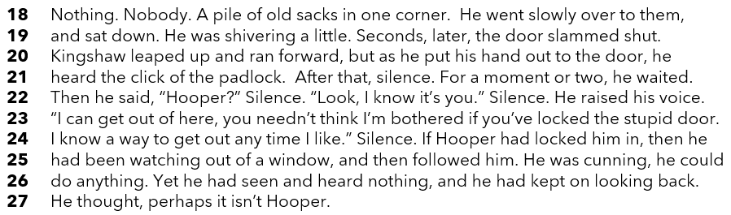
How does the writer use language here to show Kingshaw’s fears?

You could include the writer’s choice of:

• words and phrases
• language features and techniques
• sentence forms
[8 marks]

Q3: You now need to think about the structure of the source as a whole.

How has the writer structured the text to create a sense of increasing danger?

In your answer refer to:
• how a sense of danger increases or decreases by the end of the source
• how the writer uses structure to create an effect
• the writer’s use of any other structural features, such as changes in mood,
pace, tone or perspective
[8 marks]

Q4: Focus this part of your answer from line 28 to the end.

‘It’s only Kingshaw’s wild imagination that makes the shed and his situation seem dangerous.’

To what extent do you agree or disagree with this statement?

In your response you should:
- write about your impressions of the shed and his situation
- comment on the methods used to create these impressions
- support your response with references to the text [20 marks]

Section B: Writing

You are advised to spend 45 minutes on this section.
Write in full sentences.
You are reminded of the need to plan your answer.
You should leave enough time to check your work at the end

Either

Write the opening of a story in which something valuable is discovered.

Or

Write a description of a storm, as suggested by the image.



(24 marks for content and organisation
16 marks for technical accuracy)
[40 marks]

