AQA-style Language Paper 1: ‘The Hobbit’, by JJR Tolkien, published 1937
This extract is taken from a fantasy novel. Deep inside a mountain, a hobbit named Bilbo Baggins enters the lair of a dragon named Smaug and steals a golden cup.
1  2  3  4  5  6  7  8  9  10  11  12  13  14  15  16  17  18  19  20  21  22  23  24  25  26  27  28  29  30  31  32  33  34  35  36  37  38  39  40  41  42  43  44  45  46  47  48  49  50  51  52  53  54  55  56  57  58  59  60 | He was altogether alone. Soon he thought it was beginning to feel warm. Is that a kind of a glow I seem to see coming right ahead down there? he thought. It was. As he went forward it grew and grew, till there was no doubt about it. It was a red light steadily getting redder and redder. Also, it was now undoubtedly hot in the tunnel. Wisps of vapour floated up and past him and he began to sweat. A sound, too, began to throb in his ears, a sort of bubbling like the noise of a large pot galloping on the fire, mixed with a rumble as of a gigantic tom-cat purring. This grew to the unmistakable gurgling noise of some vast animal snoring in its sleep down there in the red glow in front of him.  It was at this point that Bilbo stopped. Going on from there was the bravest thing he ever did. The tremendous things that happened afterward were as nothing compared to it. He fought the real battle in the tunnel alone, before he ever saw the vast danger that lay in wait. At any rate after a short halt go on he did; and you can picture him coming to the end of the tunnel, an opening of much the same size and shape as the door above. Through it peeps the hobbit’s little head. Before him lies the great bottommost cellar or dungeon-hall of the ancient dwarves right at the Mountain’s root. It is almost dark so that its vastness can only be dimly guessed, but rising from the near side of the rocky floor there is a great glow. The glow of Smaug!  There he lay, a vast red-golden dragon, fast asleep; thrumming came from his jaws and nostrils, and wisps of smoke, but his fires were low in slumber. Beneath him, under all his limbs and his huge coiled tail, and about him on all sides stretching away across the unseen floors, lay countless piles of precious things, gold wrought and unwrought, gems and jewels, and silver red-stained in the ruddy light. Smaug lay, with wings folded like an immeasurable bat, turned partly on one side, so that the hobbit could see his underparts and his long pale belly crusted with gems and fragments of gold from his long lying on his costly bed. Behind him where the walls were nearest could dimly be seen coats of mail, helms and axes, swords and spears hanging; and there in rows stood great jars and vessels filled with a wealth that could not be guessed. To say that Bilbo’s breath was taken away is no description at all. There are no words left to express his astonishment, since Men changed the language that they learned of elves in the days when all the world was wonderful.  Bilbo had heard tales of dragon hoards before, but the splendour, the lust, the glory of such treasure had never yet come home to him. His heart was filled and pierced with enchantment and with the desire of dwarves; and he gazed motionless, almost forgetting the frightful guardian, at the gold beyond price and count.  He gazed for what seemed an age, before drawn almost against his will, he crept from the shadow of the doorway, across the floor to the nearest edge of the mounds of treasure. Above him the sleeping dragon lay, a dire menace even in his sleep. He grasped a great two-handled cup, as heavy as he could carry, and cast one fearful eye upwards. Smaug stirred a wing, opened a claw, the rumble of his snoring changed its note.  Dragons may not have much real use for all their wealth, but they know it to an ounce as a rule and Smaug was no exception. He had passed from an uneasy dream to a doze, and then to wide waking. There was a breath of strange air in his cave. Could there be a draught from that little hole? He had never felt quite happy about it, though was so small, and now he glared at it in suspicion and wondered why he had never blocked it up. Of late he had half fancied he had caught the dim echoes of a knocking sound from far above that came down through it to his lair. He stirred and stretched forth his neck to sniff. Then he missed the cup!  Thieves! Fire! Murder! Such a thing had not happened since first he came to the Mountain! His rage passes description - the sort of rage that is only seen when rich folk that have more than they can enjoy suddenly lose something that they have long had but have never before used or wanted. His fire belched forth, the hall smoked, he shook the mountain roots. He thrust his head in vain at the little hole, and then coiling his length together, roaring like thunder underground, he sped from his deep lair through its great door, out into the huge passages of the mountain palace and up towards the Front Gate.

Q1: Read again lines 1 to 9.
Answer all parts of this question.
Tick (✓) one box for each question.

- Choose a maximum of one answer for each question.
- If you make an error, put a cross through the whole box.
- If you change your mind and require an answer that has been crossed out,
then draw a circle around the box.

01.1 What causes Bilbo to sweat as he journeys through the tunnel?
He is afraid of the dark
He has been walking for a long time
The tunnel becomes hotter as he walks
[1 mark]
01.2 What does Bilbo hear as he approaches the red glow?
The snoring of a large sleeping creature
The crackling of burning firewood
The rumble of an earthquake
[1 mark]
01.3 What can we infer about Bilbo’s feelings here?
He is calm and unafraid of his surroundings
He is confident and eager to explore
He is curious but increasingly afraid
[1 mark]
01.4 What kind of vapour does Bilbo see in the tunnel?
Thick clouds of smoke filling the tunnel
Wisps floating up and past him
Mists rising from the ground outside [1mark]
Q2: Look again in detail lines 20 to 33 of the source.
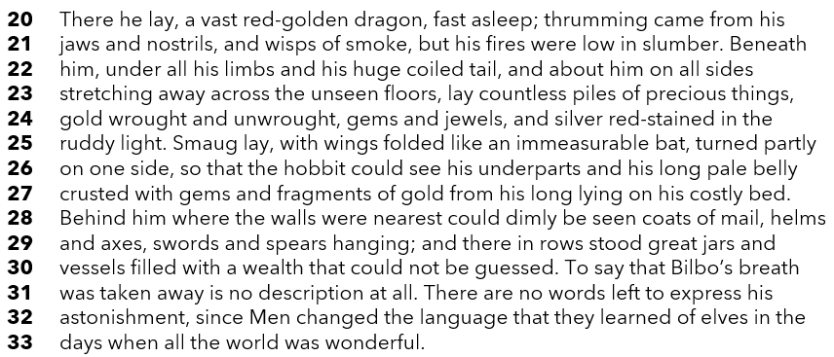

How does the writer use language here to describe the dragon and its lair?

You could write about the writer’s choice of:
- words and phrases
- language features and techniques
- sentence forms
[8 marks]

Q3: You now need to think about the structure of the source as a whole.

How has the writer structured the text to create a sense of Bilbo’s awe and wonder?

In your answer refer to:

- how a sense of awe and wonder increases or decreases by the end of the source
- how the writer uses structure to create an effect
- the writer’s use of any other structural features, such as changes in mood, pace, tone, or perspective

[8 marks]
Q4: Focus this part of your answer on lines 34 to the end of the source.
"Bilbo is more overwhelmed by the treasure than he is afraid of the dragon."
To what extent do you agree or disagree with this statement?
In your response you should:
- write about your impressions of Bilbo and his situation
- comment on the methods used to create these impressions
- support your response with references to the text [20 marks]
Section B: Writing

You are advised to spend 45 minutes on this section.
Write in full sentences.
You are reminded of the need to plan your answer.
You should leave enough time to check your work at the end

Either

Write a description of an abandoned building, as suggested by this picture

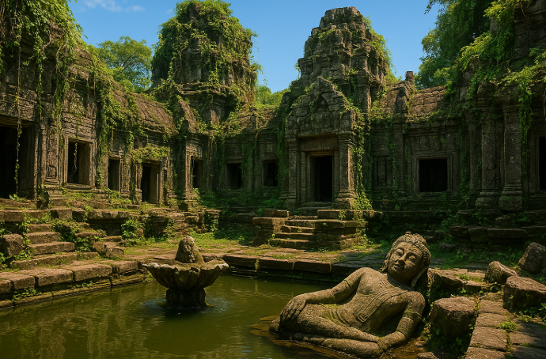

Or

Write the opening of a story which begins with someone hearing
an unexpected voice in the dark.

(24 marks for content and organisation
16 marks for technical accuracy)
[40 marks]

