AQA-style Language P1: ‘The War of the Worlds’ by HG Wells, published 1897
In this extract, taken from the beginning of a science-fiction novel, a crowd of people has gathered in a park in London to observe a cylinder-shaped alien space craft which has crash landed.
1  2  3  4  5  6  7  8  9  10  11  12  13  14  15  16  17  18  19  20  21  22  23  24  25  26  27  28  29  30  31  32  33  34  35  36  37  38  39  40  41 | The end of the cylinder was being screwed out from within. Nearly two feet of shining screw projected. Somebody blundered against me, and I narrowly missed being thrown onto the top of the screw. I turned, and as I did so the screw must have come out, for the lid of the cylinder fell upon the gravel with a ringing concussion.  I think everyone expected to see a man emerge - possibly something a little unlike us terrestrial men, but in all essentials a man. I know I did. But, looking, I presently saw something stirring within the shadow: greyish billowy movements, one above another, and then two luminous disks--like eyes. Then something resembling a little grey snake, about the thickness of a walking stick, coiled up out of the writhing middle, and wriggled in the air towards me--and then another.  A sudden chill came over me. There was a loud shriek from a woman behind. I half turned, keeping my eyes fixed upon the cylinder still, from which other tentacles were now projecting, and began pushing my way back from the edge of the pit. I saw astonishment giving place to horror on the faces of the people about me. I heard inarticulate exclamations on all sides. There was a general movement backwards. I found myself alone, and saw the people on the other side of the pit running off, Stent among them. I looked again at the cylinder, and uncontrollable terror gripped me. I stood petrified and staring.  A big greyish rounded bulk, the size, perhaps, of a bear, was rising slowly and painfully out of the cylinder. As it bulged up and caught the light, it glistened like wet leather. Two large dark-coloured eyes were regarding me steadfastly. The mass that framed them, the head of the thing, was rounded, and had, one might say, a face. There was a mouth under the eyes, the lipless brim of which quivered and panted, and dropped saliva. The whole creature heaved and pulsated convulsively. A lank tentacular appendage gripped the edge of the cylinder, another swayed in the air.  Those who have never seen a living Martian can scarcely imagine the strange horror of its appearance. The peculiar V-shaped mouth with its pointed upper lip, the absence of brow ridges, the absence of a chin beneath the wedgelike lower lip, the incessant quivering of this mouth, the Gorgon groups of tentacles, the tumultuous breathing of the lungs in a strange atmosphere, the evident heaviness and painfulness of movement due to the greater gravitational energy of the earth--above all, the extraordinary intensity of the immense eyes--were at once vital, intense, inhuman, crippled and monstrous. There was something fungoid in the oily brown skin, something in the clumsy deliberation of the tedious movements unspeakably nasty. Even at this first encounter, this first glimpse, I was overcome with disgust and dread.  Suddenly the monster vanished. It had toppled over the brim of the cylinder and fallen into the pit, with a thud like the fall of a great mass of leather. I heard it give a peculiar thick cry, and forthwith another of these creatures appeared darkly in the deep shadow of the aperture.  I turned and, running madly, made for the first group of trees, perhaps a hundred yards away; but I ran slantingly and stumbling, for I could not avert my face from these things.

01: Read again lines 1 to 10.
Answer all parts of this question.
Tick (✓) one box for each question.

- Choose a maximum of one answer for each question.
- If you make an error, put a cross through the whole box.
- If you change your mind and require an answer that has been crossed out, then draw a circle around the box.

01.1 What happens when the cylinder end is unscrewed?
The cylinder explodes
The lid crashes loudly to the ground
An astronaut appears
[1 mark]
01.2 What did the narrator expect to emerge from the cylinder?
A machine, like a robot
A man, or something similar to a man
A grey snake-like creature
[1 mark]
01.3 How are the creatures described as they begin to appear?
They are friendly and curious
They resemble human beings
They are unfamiliar and unsettling
[1 mark]
01.4 What is the narrator’s reaction to the emerging creatures?
He is surprised and perhaps fearful
He wants to attack the creatures
He calmly observes them [1 mark]
Q2. Look again in detail at lines 11 to 18 of the source.
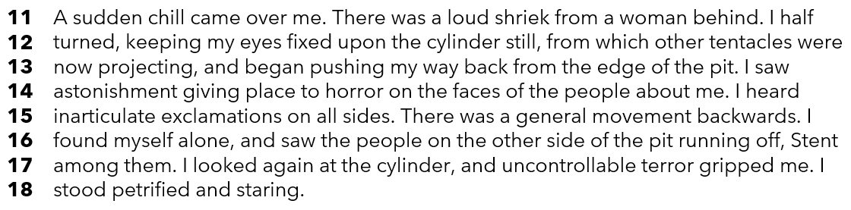
How does the writer use language here to describe the people’s reactions?
You could include the writer’s choice of:
• words and phrases
• language features and techniques
• sentence forms. [8 marks]

Q3. You now need to think about the whole of the source.
This extract was taken from the beginning of a novel.
How has the writer structured the text create a sense of alarm and fear?

You could write about:
- how a sense of alarm and fear increases and decreases by the end of the extract
- how the writer uses structure to create alarm and fear
- the writer’s use of structural features, such as changes in mood, tone or perspective

[8 marks]
Q4. Focus this part of your answer from line 19 to the end.

‘In this part of the source, the writer skilfully brings to life the horror of the
creature's appearance for the reader. The alien is a truly dreadful creature.’

To what extent do you agree or disagree with this statement?

In your response, you should:
• write about your own impressions of the alien creature
• comment on the methods used by the writer to create these impressions
• support your response with references to the text. [20 marks]

Section B: Writing

You are advised to spend 45 minutes on this section.
Write in full sentences.
You are reminded of the need to plan your answer.
You should leave enough time to check your work at the end

Either

Write the opening of a story in which a meeting does not go as planned.

Or

Write a description of a peaceful place where nature is disturbed by movement, as suggested by the image.



(24 marks for content and organisation
16 marks for technical accuracy)
[40 marks]

