AQA-style Language Paper 1: ‘White Fang’ by Jack London, published 1906

In this extract, set on a ranch called Sierra Vista in America, White Fang is a dog, guarding the house of the Scott family: Judge Scott, the judge’s wife and the judge’s son, Weedon Scott (whom White Fang calls ‘the love master’). In the middle of the night an escaped murderer named Jim Hall breaks into the house to try and murder the judge. White Fang refers to Jim Hall as ‘the strange god’.

1  2  3  4  5  6  7  8  9  10  11  12  13  14  15  16  17  18  19  20  21  22  23  24  25  26  27  28  29  30  31  32  33  34  35  36  37  38  39  40  41  42  43  44  45  46  47  48 | One night, while all the house slept, White Fang awoke and lay very  quietly. And very quietly he smelled the air and read the message it  bore of a strange god's presence. And to his ears came sounds of  the strange god's movements. White Fang burst into no furious  outcry. It was not his way. The strange god walked softly, but more  softly walked White Fang, for he had no clothes to rub against the  flesh of his body. He followed silently. In the Wild he had hunted live  meat that was infinitely¹ timid², and he knew the advantage of surprise.  The strange god paused at the foot of the great staircase and listened,  and White Fang was as dead, so without movement was he as he  watched and waited. Up that staircase the way led to the love-master  and to the love- master's dearest possessions. White Fang bristled³,  but waited. The strange god's foot lifted. He was beginning the ascent.  Then it was that White Fang struck. He gave no warning, with no snarl  anticipated his own action. Into the air he lifted his body in the spring  that landed him on the strange god's back. White Fang clung with his  fore-paws to the man's shoulders, at the same time burying his fangs  into the back of the man's neck. He clung on for a moment, long enough  to drag the god over backward. Together they crashed to the floor.  White Fang leaped clear, and, as the man struggled to rise, was in  again with the slashing fangs.  Sierra Vista awoke in alarm. The noise from downstairs was as that of  a score of battling fiends. There were revolver shots. A man's voice  screamed once in horror and anguish. There was a great snarling and  growling, and over all arose a smashing and crashing of furniture and glass.  But almost as quickly as it had arisen, the commotion died away. The  struggle had not lasted more than three minutes. The frightened  household clustered at the top of the stairway. From below, as from out  of an abyss⁴ of blackness, came up a gurgling sound, as of air bubbling  through water. Sometimes this gurgle became sibilant⁵, almost a whistle.  But this, too, quickly died down and ceased. Then naught came up out  of the blackness save a heavy panting of some creature struggling sorely for air.  Weedon Scott pressed a button, and the staircase and downstairs hall  were flooded with light. Then he and Judge Scott, revolvers in hand,  cautiously descended. There was no need for this caution. White Fang  had done his work. In the midst of the wreckage of overthrown and  smashed furniture, partly on his side, his face hidden by an arm, lay a  man. Weedon Scott bent over, removed the arm and turned the man's  face upward. A gaping throat explained the manner of his death.  "Jim Hall," said Judge Scott, and father and son looked significantly  at each other.  Then they turned to White Fang. He, too, was lying on his side. His  eyes were closed, but the lids slightly lifted in an effort to look at them  as they bent over him, and the tail was perceptibly⁶ agitated⁷ in a vain⁸  effort to wag. Weedon Scott patted him, and his throat rumbled an  acknowledging growl. But it was a weak growl at best, and it quickly  ceased. His eyelids drooped and went shut, and his whole body  seemed to relax and flatten out upon the floor.

Glossary:

¹ infinitely - extremely

² timid – shy

³ bristled – stiffened and rose his head

⁴ abyss – a gulf, a hole.

⁵ sibilant – hissing.

⁶ perceptibly – noticeably, visibly

⁷ agitated – stressed, nervous

⁸ vain – hopeless.

Q1: Read again lines 1 to 8.
Answer all parts of this question.
Tick (✓) one box for each question.

- Choose a maximum of one answer for each question.
- If you make an error, put a cross through the whole box.
- If you change your mind and require an answer that has been crossed out, then draw a circle around the box.

01.1 What does White Fang do in this paragraph?
White Fang attacks the stranger
White Fang follows silently
White Fang lets out a low growl
[1 mark]
01.2 What does White Fang’s experience in the wild show?
It shows he is inexperienced
It shows he is protective of his pack
It shows he knows the value of surprise
[1 mark]
01.3 What does White Fang notice about the ‘strange god’?
He notices the strange god walks very softly
He notices that the strange god is noisy
He notices that the strange god is clumsy
[1 mark]
01.4 Which phrase shows White Fang is more careful than the stranger?
“Burst into no furious outcry”
“More softly walked White Fang”
“Hunted live meat that was timid”
[1 mark]

Q2: Look in detail at this extract from lines 9 to 21 of the source.
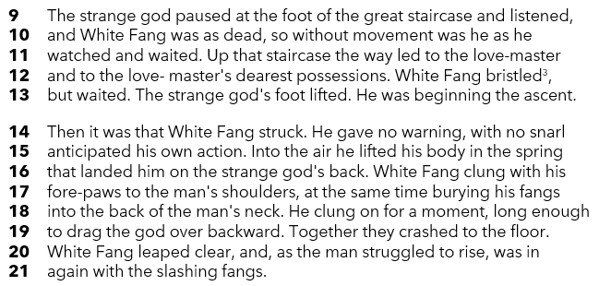

How does the writer use language here to show the excitement
of White Fang’s attack on the intruder?

You could include the writer’s choice of:
- words and phrases
- language features and techniques
- sentence forms.
[8 marks]

Q3: You now need to think about the structure of the source as a whole.
How has the writer structured the text to create a sense of tension?
You could write about:
- how tension increases or decreases by the end of the source
- how the writer uses structure to create these effects
- the writer’s use of any other structural features, such as changes in mood, pace, or focus
[8 marks]

Q4 Focus your answer on lines 22 to the end of the source.
In this part of the source, the writer vividly portrays the chaos and drama of the struggle in the house.
To what extent do you agree or disagree with this statement?
In your response, you should:
- write about your own impressions of the struggle and its aftermath
- comment on the methods used by the writer to create these impressions
- support your response with references to the text
[20 marks]

Section B: Writing

You are advised to spend 45 minutes on this section.
Write in full sentences.
You are reminded of the need to plan your answer.
You should leave enough time to check your work at the end

Either

Write a description of a wintery scene, as suggested by this picture

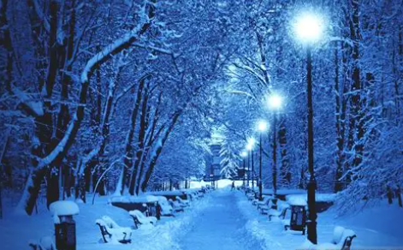

Or

Write a description of an animal that has made a strong impression on you.

(24 marks for content and organisation
16 marks for technical accuracy)
[40 marks]

