AQA=style Language Paper 1: ‘Z for Zachariah’, by Robert O’Brien, published 1974
This extract, written in the form of a diary, is narrated by a 16 years old girl named Ann Burden. She is the only survivor in her town after a nuclear war. She thinks someone is coming and that she is no longer alone. Is this person a friend or is she in danger?
1  2  3  4  5  6  7  8  9  10  11  12  13  14  15  16  17  18  19  20  21  22  23  24  25  26  27  28  29  30  31  32  33  34  35  36  37  38  39  40  41  42  43  44  45  46 | May 20th  I am afraid. Someone is coming. That is, I think someone is coming, though I am not sure, and I pray that I am wrong. I went into the church and prayed all this morning. I sprinkled water in front of the altar, and put some flowers on it, violets and dogwood. But there is smoke. For three days there has been smoke, not like the time before. That time, last year, it rose in a great cloud a long way away, and stayed in the sky for two weeks. A forest fire in the dead woods, and then it rained and the smoke stopped. But this time it is a thin column, like a pole, not very high.  And the column has come three times, each time in the late afternoon. At night I cannot see it, and in the morning, it is gone. But each afternoon it comes again, and it is nearer. At first it was behind Claypole Ridge, and I could see only the top of it, the smallest smudge. I thought it was a cloud, except that it was too grey, the wrong colour, and then I thought: there are no clouds anywhere else. I got the binoculars and saw that it was narrow and straight; it was smoke from a small fire. When we used to go in the truck, Claypole Ridge was fifteen miles, though it looks closer, and the smoke was coming from behind that.  Beyond Claypole Ridge there is Ogdentown, about ten miles further. But there is no one left alive in Ogdentown. I know, because after the war ended, and all the telephones went dead, my father, my brother Joseph and my Cousin David went in the truck to find out what was happening, and the first place they went was Ogdentown. They went early in the morning: Joseph and David were really excited, but Father looked serious.  When they came back it was dark. Mother had been worrying – they took so long – so we were glad to see the truck lights finally coming over Burden hill, six miles away. They looked like beacons. They were the only lights anywhere, except in the house – no other cars had come down all day. We knew it was the truck because one of the lights, the left one, always blinked when it went over a bump. It came up to the house and they got out; the boys weren’t excited any more. They looked scared, and my father looked sick. Maybe he was beginning to be sick, but mainly I think he was distressed. My mother looked up at him as he climbed down.  “What did you find?”  He said, “Bodies. Just dead bodies. They’re all dead.”  “All?”  We went inside the house where the lamps were lit, the two boys following, not saying anything. My father sat down. “Terrible,” he said, and again, “terrible, terrible. We drove around, looking. We blew the horn. Then we went to the church and rang the bell. You can hear it five miles away. We waited for two hours, but nobody came. I went into a couple of houses – the Johnsons’ the Peters’ – they were all in there, all dead. There were dead birds all over the streets.”  My brother Joseph began to cry. He was fourteen. I think I had not heard him cry for six years.  May 21st  It is coming closer. Today it was almost on top of the ridge, though not quite, because when I looked with the binoculars, I could not see the flame, but still only the smoke – rising very fast, not far above the fire. I know where it is: at the crossroads. Just on the other side of the ridge, the east-west highway, the Dean Town Road, crosses our road. It is route number nine, a State highway, bigger than our road, which is County road 793. He has stopped there and is deciding whether to follow number nine or come over the ridge. I say he because that is what I think of, though it could be they or even she. But I think it is he. If he decides to follow the highway he will go away, and everything will be all right again. Why would he come back? But if he comes to the top of the ridge, he is sure to come down here, because he will see the green leaves. On the other side of the ridge, even on the other side of Burden Hill, there are no leaves; everything else is dead.

Q1: Read again lines 1 to 6.
Answer all parts of this question.
Tick (✓) one box for each question.

- Choose a maximum of one answer for each question.
- If you make an error, put a cross through the whole box.
- If you change your mind and require an answer that has been crossed out, then draw a circle around the box.

01.1 What does the narrator do after feeling afraid?
She runs away into the forest
She watches the smoke from the hill
She prays in the church
[1 mark]
01.2 What things does the narrator place in the church?
A pile of stones
Violets and dogwood flowers
Branches from oak and birch trees
[1 mark]
01.3 What does the narrator’s reaction to seeing the smoke suggest?
It suggests she lives in fear and isolation
It suggests she is used to seeing people
It suggests she is unconcerned
[1 mark]
01.4 How does the narrator describe the smoke she sees?
A thick cloud that fills the sky
A thin column, like a pole
A spiral of mist drifting across the valley
[1 mark]

Q2: Read again in detail lines 19 to 34 of the source.
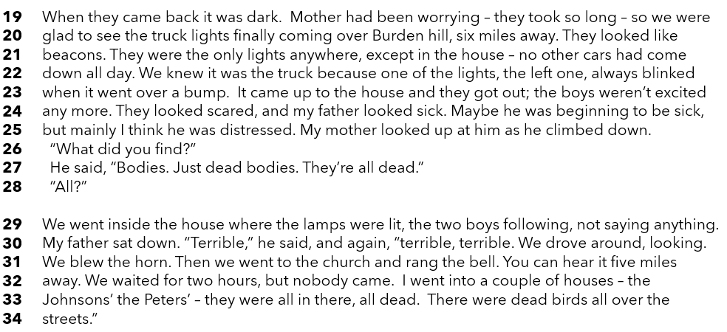

How does the writer use language here to suggest the family’s fear and horror?
You could write about the writer’s choice of:
- words and phrases
- language features and techniques
- sentence forms [8 marks]

Q3: Now you need to think about the structure of the source as a whole.
How has the writer structured the text to create suspense?
You could write about:
• how suspense has increased or decreased by the end of the source
• how the writer uses structure to create an effect
• the writer’s use of any other structural features, such as changes in mood,
tone or perspective
[8 marks]

Q4: Focus this part of your answer from line 23 to the end of the extract.
“In this part of the source, the writer highlights the devastating impact of nuclear war, not only on nature but also on the people who manage to survive.”
To what extent do you agree or disagree with this statement?
In your response you could
• consider your impressions of the impact of war on Nature and people
• comment on the methods the writer uses to present them both
• support your response with references to the text
[20 marks]

Section B: Writing

You are advised to spend 45 minutes on this section.
Write in full sentences.
You are reminded of the need to plan your answer.
You should leave enough time to check your work at the end

Either

Write the opening of a story where an important secret is about to be revealed.

Or

Write a description of a gloomy place, as suggested by the image.

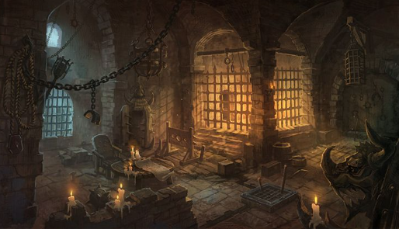

(24 marks for content and organisation
16 marks for technical accuracy)
[40 marks]

