AQA English Language Paper 2A:
Writers’ Viewpoints and Perspectives

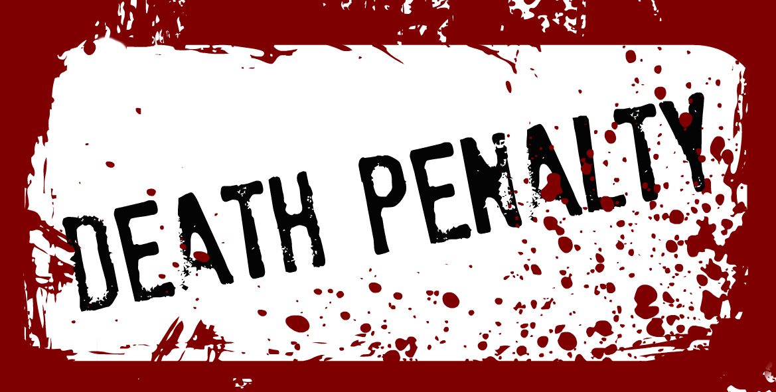

Two non-fiction texts linked
by the same theme or topic

SOURCE A: The author of this essay (published in 1931) is English author George Orwell, who served in the British Imperial Police, in Burma, India from 1922-1927. Here, he describes a criminal being sent to his death in India.

1  2  3  4  5  6  7  8  9  10  11  12  13  14  15  16  17  18  19  20  21  22  23  24  25  26  27  28  29  30  31  32  33  34  35  36  37 | It was in Burma, a sodden morning of the rains. A sickly light, like yellow tinfoil, was  slanting over the high walls into the jail yard. We were waiting outside the condemned cells, a  row of sheds fronted with double bars, like small animal cages. Each cell measured about ten feet  by ten and was quite bare within except for a plank bed and a pot of drinking water. In some of  them brown silent men were squatting at the inner bars, with their blankets draped round them.  These were the condemned men, due to be hanged within the next week or two.  One prisoner had been brought out of his cell. He was a Hindu, a puny wisp of a man,  with a shaven head and vague liquid eyes. He had a thick, sprouting moustache, absurdly too big  for his body, rather like the moustache of a comic man on the films. Six tall Indian warders were  guarding him and getting him ready for the gallows. Two of them stood by with rifles and fixed  bayonets, while the others handcuffed him, passed a chain through his handcuffs and fixed it to  their belts, and lashed his arms tight to his sides. They crowded very close about him, with their hands always on him in a careful, caressing grip, as though all the while feeling him to make sure  he was there. It was like men handling a fish which is still alive and may jump back into the  water. But he stood quite unresisting, yielding his arms limply to the ropes, as though he hardly  noticed what was happening.  Eight o'clock struck and a bugle call, desolately thin in the wet air, floated from the  distant barracks. The superintendent of the jail, who was standing apart from the rest of us,  moodily prodding the gravel with his stick, raised his head at the sound. He was an army doctor,  with a grey toothbrush moustache and a gruff voice. ‘For God's sake hurry up, Francis,’ he said  irritably. ‘The man ought to have been dead by this time. Aren't you ready yet?’  Francis, the head jailer, a fat man in a white drill suit and gold spectacles, waved his hand. ‘Yes sir, yes sir,’ he bubbled. ‘All is satisfactorily prepared. The hangman is waiting. We shall proceed.’  ‘Well, quick march, then. The prisoners can't get their breakfast till this job's over.’  We set out for the gallows. Two warders marched on either side of the prisoner, with  their rifles at the slope; two others marched close against him, gripping him by arm and shoulder,  as though at once pushing and supporting him.  It is curious, but till that moment I had never realised what it means to destroy a healthy,  conscious man. When I saw the prisoner step aside to avoid the puddle, I saw the mystery, the  unspeakable wrongness, of cutting a life short when it is in full tide. This man was not dying, he  was alive just as we were alive. All the organs of his body were working — bowels digesting  food, skin renewing itself, nails growing, tissues forming — all toiling away in solemn foolery.  His nails would still be growing when he stood on the drop, when he was falling through the air  with a tenth of a second to live. His eyes saw the yellow gravel and the grey walls, and his brain  still remembered, foresaw, reasoned — reasoned even about puddles. He and we were a party of  men walking together, seeing, hearing, feeling, understanding the same world; and in two  minutes, with a sudden snap, one of us would be gone — one mind less, one world less.

SOURCE B: Taken from a report, published in America in 2013, titled: ‘A Death Before Dying: Solitary Confinement on Death Row’ about the conditions of prisoners awaiting execution in America.

1  2  3  4  5  6  7  8  9  10  11  12  13  14  15  16  17  18  19  20  21  22  23  24  25  26  27  28  29  30  31  32  33  34  35  36  37  38  39  40 | Nationally, more than 3,000 prisoners are confined on death rows in 35 American states.  According to the American Bar Association’s Standards for the Treatment of Prisoners, death row prisoners, while permissibly separated from other prisoners, should be housed in conditions comparable to those in general prison population. Administrative segregation or solitary confinement should only be used for brief periods for reasons related to discipline, security, or crime. Despite this clear best practice standard, the overwhelming majority of death-penalty states confine death row prisoners in solitary confinement. Our survey revealed that the vast majority of American states confine death row prisoners in segregation or solitary-type conditions based solely on their death sentences. Simply put, they are condemned to solitary for life, a kind of death before dying.  Death row prisoners are housed alone in tiny cells, ranging from just 6 feet by 6 feet to little more than 10 feet by 10 feet. Most are the size of an average bathroom. Most cells generally contain a steel bed or concrete slab, steel toilet, and small writing table. The majority of death row prisoners eat alone in their cells, fed on trays inserted through a slot in the door. They also receive the majority of their medical and mental health care through these slots. Face-to-face contact with another human being is rare.  While death row prisoners fight for their lives in these failed and failing systems, they spend years and years subjected to the devastating effects of solitary confinement. Ultimately, some will “volunteer” to die rather than continue to live under such conditions. Many will be broken beyond repair - their minds gone before the state ever executes them. All will suffer needlessly.  Regardless of their stance on the death penalty, the people of the United States understand that a fair justice system must be a humane justice system. And by this measure, we are currently failing. It is time for reformers on both sides of the death penalty debate to recognise the hidden harms of solitary confinement inflicted on death row prisoners across the country. Solitary confinement is not part of the prison sentence. In order to build a criminal justice system that accurately reflects our values, we must end the routine use of solitary confinement of death row prisoners.  Jeanne Woodford, former warden of San Quentin State Prison in California said:  “As a former warden at San Quentin and life-long corrections professional, I know that safety for staff, prisoners, and the public is the utmost concern. But I also know we can do this in a humane way. Death rows should be designed to allow prisoners to leave their cells, participate in programs, and spend time on the yard without coming into physical contact with staff, but where they can be observed by staff visually, such as through screen or glass. Where prisoners are well-behaved, 23 hours of solitary confinement in their prison cell each day is ridiculous. Conditions of confinement should be determined by behaviour. Prisoners should be able to earn their way into the least restrictive conditions consistent with meeting safety concerns. Privileges and incentives, like educational programs, contact visits, and phone calls, should be used to achieve the best security. The damage done to people through solitary confinement on death row is unnecessary and avoidable; fixing this problem is consistent with my number one concern, which is our overall public safety.”

Q1: Read lines 1 to 6 of Source A.
Shade four statements below which are TRUE. [4 marks]

- Prison cells contained only a plank bed and a water pot.

- The prisoners were all talking loudly in their cells.

- The cells measured ten feet by ten feet.

- There were some animals kept in small cages.

- Some prisoners sat silently in their cells.

- Prison cells contained only a plank bed.

- Some prisoners used a blanket to keep warm and dry.

Q2: Refer to Source A and Source B.
What do you infer about the similar ways in which the prisoners
are imprisoned? [8 Marks]

Q3: Refer to Source A.
How does the writer use language to convey his thoughts and feelings about
the prisoner being sent to his death.
[12 Marks]

Q4: Refer to Source A and Source B.

Compare how the writers convey their similar thoughts and feelings on the
death penalty and prisoners awaiting execution. [16 Marks]
In your answer, you should:

- compare their similar attitudes and feelings
- comment on the methods they use to convey their attitudes and feelings
- support your response with references to both texts

Section B: Writing
You are advised to spend 45 minutes on this section.
You are reminded of the need to plan your answer.
Leave time at the end to check through your work.

Q5: “To take a life when a life has already been lost is revenge, it is not justice. The
death penalty is barbaric and has no place in a society that calls itself civilised.”

Write an article for your school newsletter, explaining your views on this subject.
24 marks for content
16 for technical accuracy
40 marks in total

