POWER AND CONFLICT REVISION – QUESTION BOOKLET


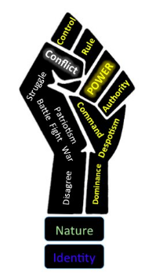



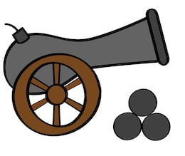






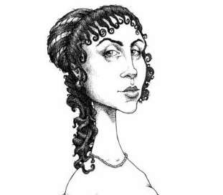











Power and Conflict
The poems you have studied are:
Percy Bysshe Shelley Ozymandias
William Blake London
William Wordsworth The Prelude: Stealing The Boat
Robert Browning My Last Duchess
Alfred Lord Tennyson The Charge of the Light Brigade
Wilfred Owen Exposure
Seamus Heaney Storm on the Island
Ted Hughes Bayonet Charge
Simon Armitage Remains
Jane Weir Poppies
Carol Ann Duffy War Photographer
Imtiaz Dharker Tissue
Carol Rumens The émigrée
Beatrice Garland Kamikaze
John Agard Checking Out Me History

Compare the ways poets present ideas about identity in The Emigrée and in one other poem from Power and Conflict.

The Émigree

There once was a country… I left it as a child
but my memory of it is sunlight-clear
for it seems I never saw it in that November
which, I am told, comes to the mildest city.
The worst news I receive of it cannot break
my original view, the bright, filled paperweight.
It may be at war, it may be sick with tyrants,
but I am branded by an impression of sunlight.

The white streets of that city, the graceful slopes
glow even clearer as time rolls its tanks
and the frontiers rise between us, close like waves.
That child’s vocabulary I carried here
like a hollow doll, opens and spills a grammar.
Soon I shall have every coloured molecule of it.
It may by now be a lie, banned by the state
but I can’t get it off my tongue. It tastes of sunlight.

I have no passport, there’s no way back at all
but my city comes to me in its own white plane.
It lies down in front of me, docile as paper;
I comb its hair and love its shining eyes.
My city takes me dancing through the city
of walls. They accuse me of absence, they circle me.
They accuse me of being dark in their free city.
My city hides behind me. They mutter death,
and my shadow falls as evidence of sunlight.

CAROL RUMENS

Compare the ways poets present ideas of suffering in London and in one other poem from Power and Conflict.

London

I wander through each chartered street,
Near where the chartered Thames does flow,
And mark in every face I meet
Marks of weakness, marks of woe.

In every cry of every man,
In every infant’s cry of fear,
In every voice, in every ban,
The mind-forged manacles I hear:

How the chimney-sweeper’s cry
Every black’ning church appalls,
And the hapless soldier’s sigh
Runs in blood down palace walls.

But most through midnight streets I hear
How the youthful harlot’s curse
Blasts the new-born infant’s tear,
And blights with plagues the marriage hearse.

WILLIAM BLAKE

Compare the ways poets present the effects of war in Remains and in one other poem from Power and Conflict.
Remains

On another occasion, we get sent out
to tackle looters raiding a bank.
And one of them legs it up the road,
probably armed, possibly not.

Well myself and somebody else and somebody else
are all of the same mind,
so all three of us open fire.
Three of a kind all letting fly, and I swear

I see every round as it rips through his life –
I see broad daylight on the other side.
So we’ve hit this looter a dozen times
and he’s there on the ground, sort of inside out,

pain itself, the image of agony.
One of my mates goes by
and tosses his guts back into his body.
Then he’s carted off in the back of a lorry.

End of story, except not really.
His blood-shadow stays on the street, and out on patrol
I walk right over it week after week.
Then I’m home on leave. But I blink

and he bursts again through the doors of the bank.
Sleep, and he’s probably armed, possibly not.
Dream, and he’s torn apart by a dozen rounds.
And the drink and the drugs won’t flush him out –

he’s here in my head when I close my eyes,
dug in behind enemy lines,
not left for dead in some distant, sun-stunned, sand-smothered land
or six-feet-under in desert sand,

but near to the knuckle, here and now,
his bloody life in my bloody hands.

SIMON ARMITAGE

